Access and Equity Navigation
From the Access and Equity homepage you can navigate directly to any of the four modules by clicking on the picture or the link. Below is a screen capture of the homepage that each learner will see after entering the course.
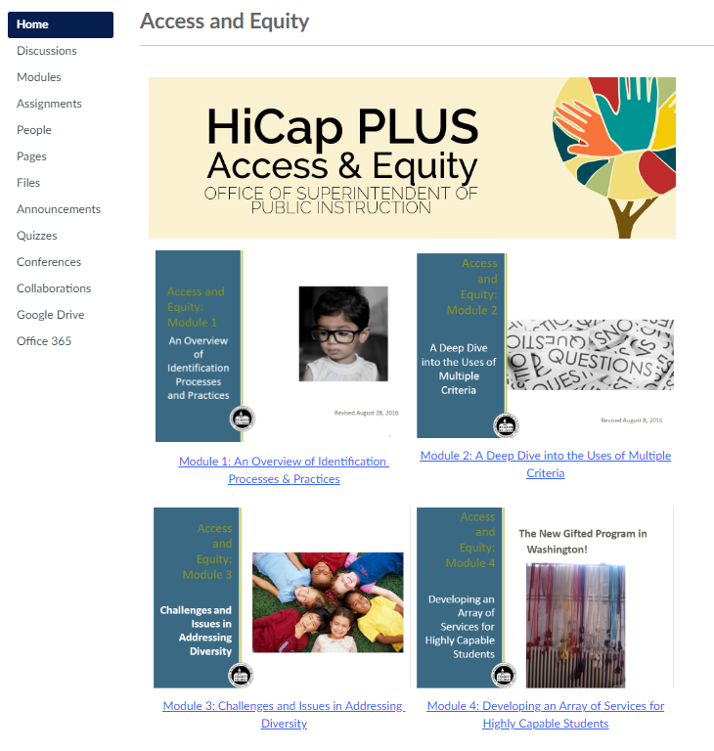
The sidebar will direct you to other portions of the course you’ll use throughout each module.
The “Discussion” section is where individuals can respond to question prompts in a group setting.
“Modules” are the bulk of the course and where all content is housed. This is the section of CANVAS where you’ll find materials to read and watch, provided by our University partners.
“Assignments” are like the “Discussion” section but are solely for an individual and their facilitator to review. The same question prompts housed in the “Discussion” section can be found here.
“People” is a list of all active participants in your current iteration of the Access and Equity course.
“Pages” currently only contains the Homepage.
“Files” contains all the individual content pieces, in a format structured similar to what you might find on a computer. If you’re looking for an individual piece of work, or would like to search by key phrase or word, this would be the spot to check.
“Quizzes” should not be thought of as actual quizzes for this course. Instead, these will act as checks for understanding at the start and end of each module. They will not be graded and are structured like surveys. Unfortunately we do not have the ability to change the name or “Quizzes” to anything else.
If you need further help navigating, CANVAS provides an excellent rundown of services through their CANVAS Guides
If you cannot find what you’re looking for there, you’re welcome to contact Ben King, our Content Specialist with the JAVITS grant, at ben.king@k12.wa.us

